**DAY-1**

1**. Roadmaps (Roadmap.sh)**

* Backend
* Java
* SpringBoot

Explore below links:

* <https://roadmap.sh/backend>
* <https://roadmap.sh/java>
* <https://roadmap.sh/spring-boot>

2. **Agile - Scrum model & various meetings during SDLC**

**Agile -** Agile is “Timebox based iterative approach for software development”.

**Agile** is a **flexible, iterative approach** that delivers work in **small increments**, adapting to feedback and changes quickly.

**Scrum – An Agile Framework**

Scrum is a lightweight, iterative, and incremental Agile framework used for managing complex projects, especially in software development. It focuses on collaboration, flexibility, continuous improvement, and delivering value quickly.

**Why Use Scrum?**

* **Faster Delivery** – Work is done in small, iterative cycles.
* **More Flexibility** – Can adapt to **changing requirements**.
* **Better Collaboration** – Continuous communication within the team .
* **Higher Quality** – Regular feedback ensures **continuous improvement**.

**Timebox** – 1 week, 2 week , 3 week

**Sprint** – Time frame like 1 week or 2 week.

**Sprint** - A **Sprint** is a time-boxed iteration in Scrum, during which the team works on a set of prioritized tasks to deliver a potentially shippable product increment.

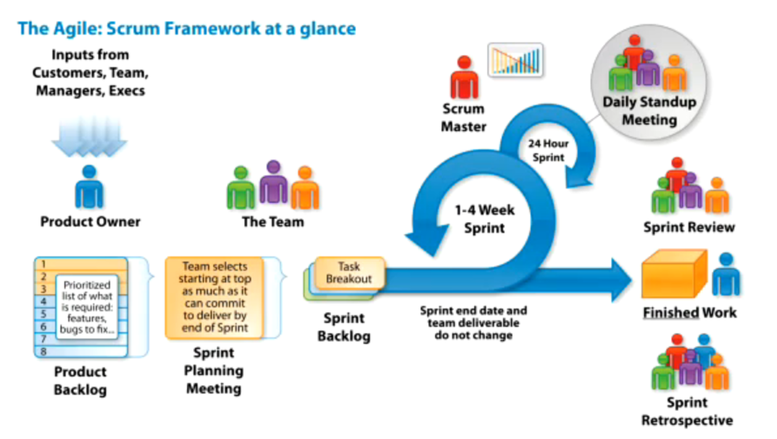

**Meetings :**

1. Refinement Process/Grooming/Requirement gathering meeting :

* Requirement will be discussed with the tech team that on what function we have to work on.
* What needs to be developed.
* Tech team will ask questions and get clarified.

2. Sprint Planning meeting :

* At day -1 of the sprint.
* Team decides how many features we can finished during this sprint.
* Don’t count weekends.

Multiple developers

Frontend/Backend DBA Integration Tester – heavy load

It may lead to not delivering features at end of sprint .

so introduced,

3. Daily standup meeting (Scrum) :

* Everyday at beginning of the day.
* Every team member is supposed to give their status update.
* What you were doing yesterday.
* What is plan for today.
* Are we on track to finish the work.
* Do you need from other team member.

4. Sprint Review / Sprint Demo : (Grab opportunity to showcase yourself)

* Happens at end of sprint.
* You give demo to client of what features are developed in sprint.
* Show databases, show logs, explain features end to end.

5. Retrospective meeting :

* Learn from last sprint.
* Solve and raise your problems you faced during sprint.
* What went right
  + Repeat in next sprint.
* What went wrong
  + Don’t repeat.
* New Initiatives

**Exercise:**

3 Bullet points:

* Iterative approach for software development
* Sprint – 2 weeks timebox

**Understand responsibility of each role:**  
👉 **PO** decides WHAT to build 🎯  
👉 **SM** ensures HOW it's built smoothly 🚀  
👉 **Team** does the WORK & delivers

**Product Owner (PO) = The Director 🎬**

* **Communicates with** business people and others and figure out the actual requirement.
* Gives requirements.
* Decides what features are most important (the **scenes**).
* Works with stakeholders to refine the script (**backlog management**).
* Ensures the final product meets expectations (**acceptance criteria**).

**Scrum Master (SM) = The Producer 🎥**

* Ensure that sprint process should run smoothly.
* Ensure Project owner gave all the requirements.
* Features are done within sprint time.
* Daily Standup are going properly.
* If Anyone facing issue let me solve.

**Development Team**

* Transforms the vision into reality (**builds the product**).
* Works together to deliver high-quality work (**self-organizing**).
* Communicates progress and challenges (**daily stand-ups**).
* Ensures each Sprint delivers a **"blockbuster" increment**.

**Jira - End-to-End Project Management Tool**

My account - <https://sameerkhatridev512.atlassian.net/jira/software/projects/SCRUM/boards/1/backlog>

**Backlog** – Product backlog

* upcoming functional requirements will be there.
* Arranged in priority what the need first to be done.
* Tech team pick function to develop from top.

**PO works in Jira :**

1. Product owner arrange these function in priority.
2. Requirements will be written as user stories, Each story has unique id.
3. Arrange in priority.
4. Clarification and update to requirement will happen.
5. Jira should always reflect final state of requirement. you have to develop according to jira.
6. 3-4 features are discussed in refinement meeting.
7. Sprint planning meeting time

* 3 features

1. Who will work on what features?
   * Task breakdown and work allocation

Create below child subtask for user story

* UI task
* Server task
* QA Testcase
* QA Excecution

Assign task to right person.

9. Start the Sprint

Select duration for sprint.

==Tomorrow Task==

Rest API

Deploy on AWS (linux based commands)